EUROPEAN VEGETATION SURVEY

15th Workshop - CATANIA (Italy), March 26-30, 2006

IMAGES FROM FIELD-EXCURSION
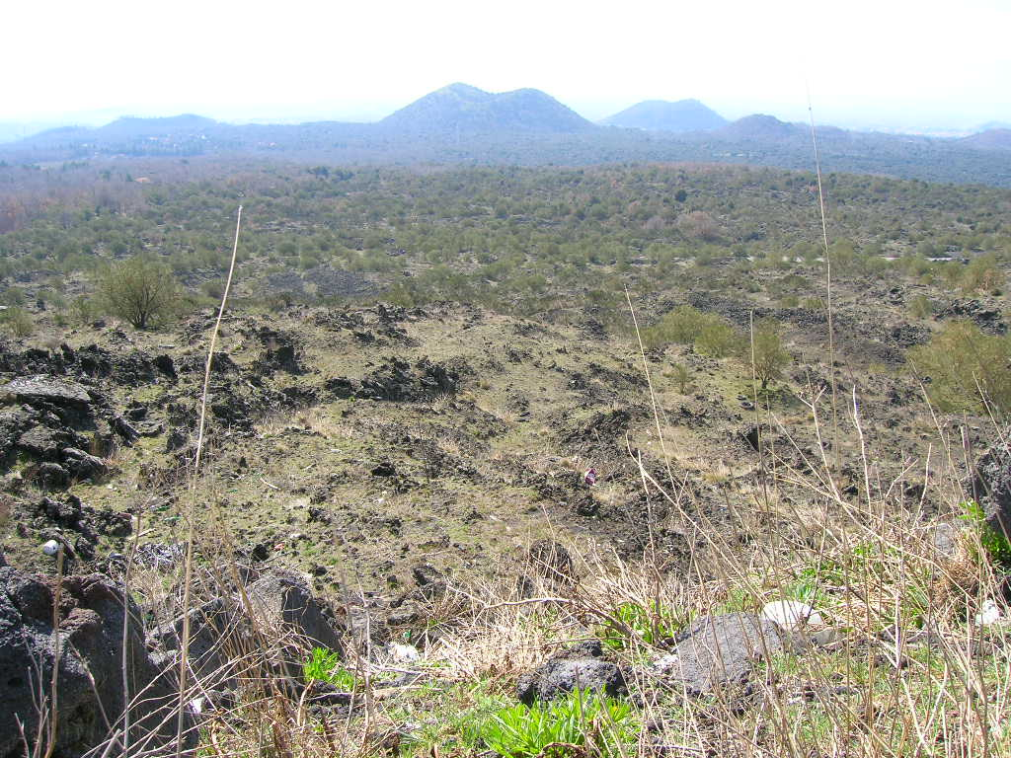
Monte Etna - Sicily
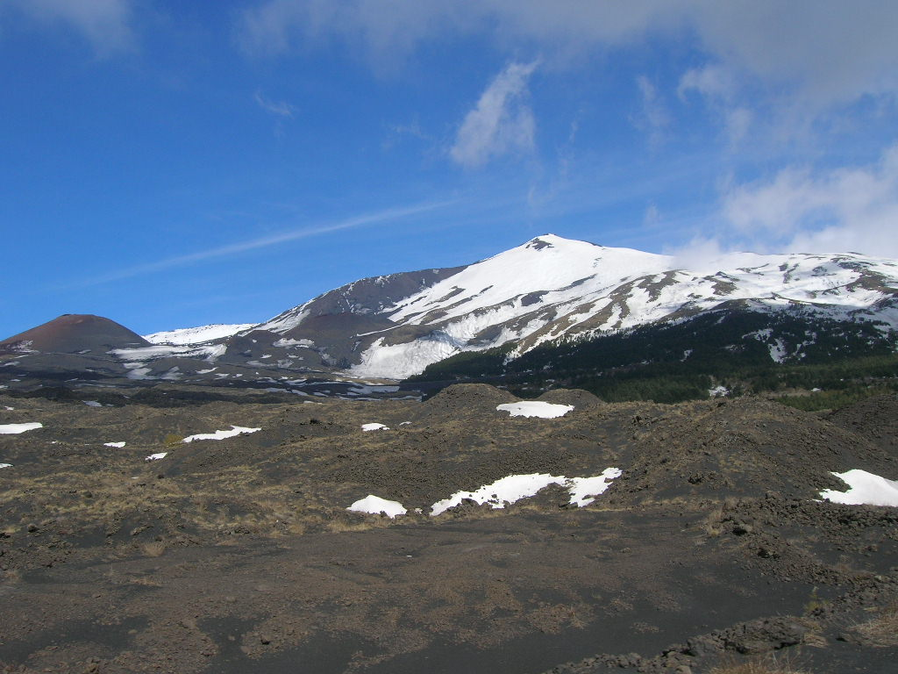
Monte Etna - Sicily
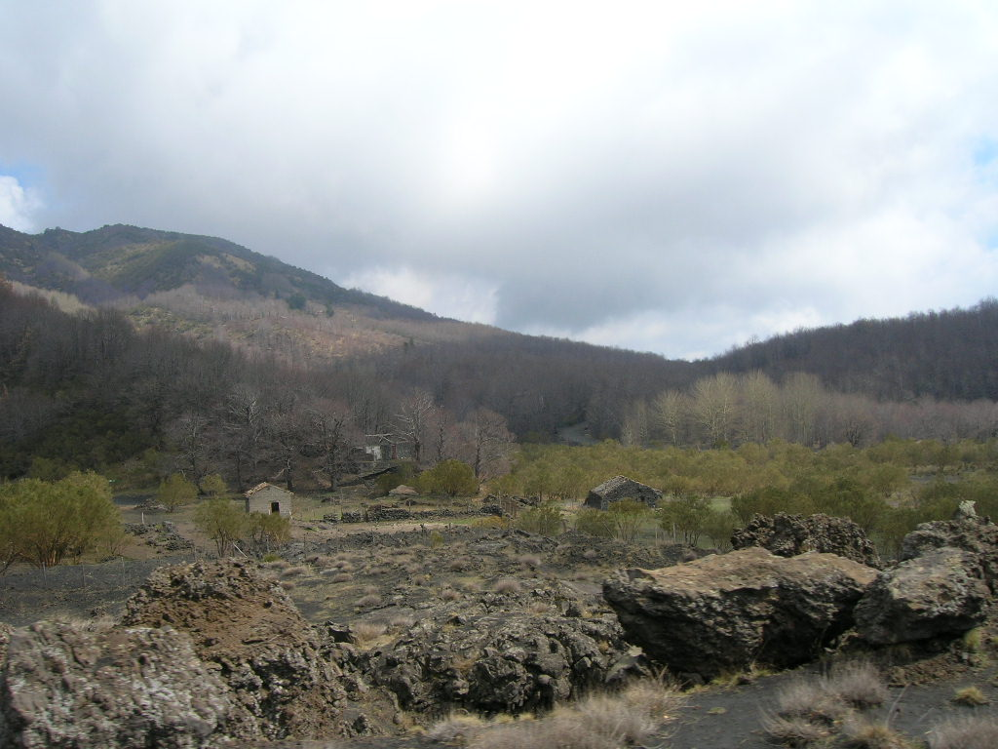
Monte Etna – Sicily (Genista aetnensis sites and Quercus cerris and Castnea Sativa forest)
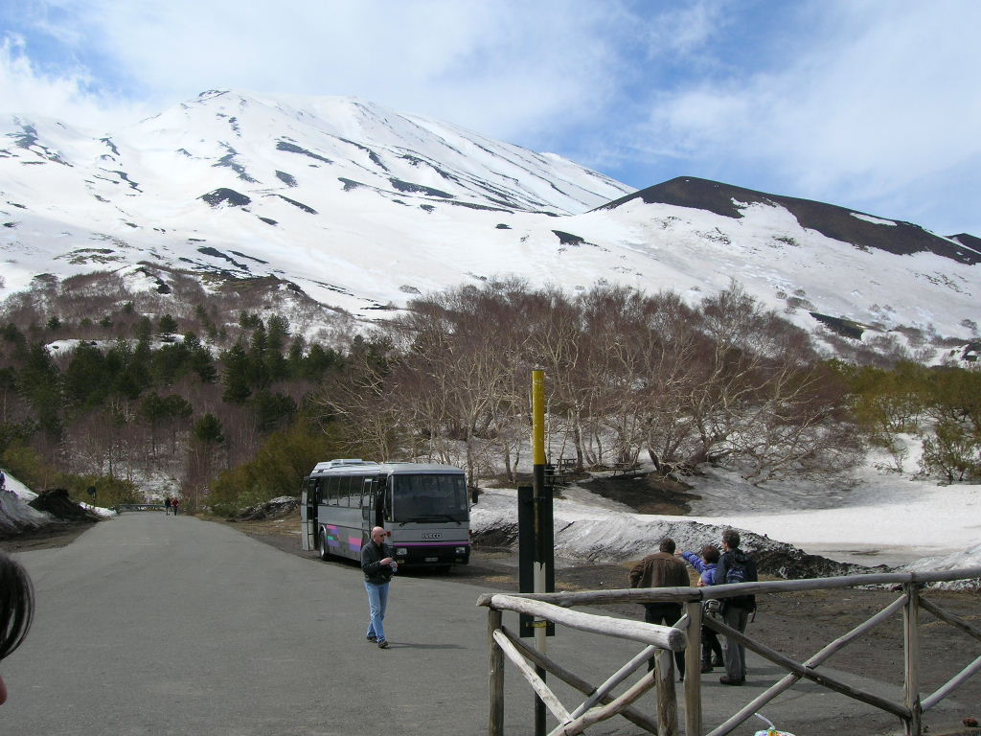
Monte Etna - Sicily (Betula aetnensis sites)
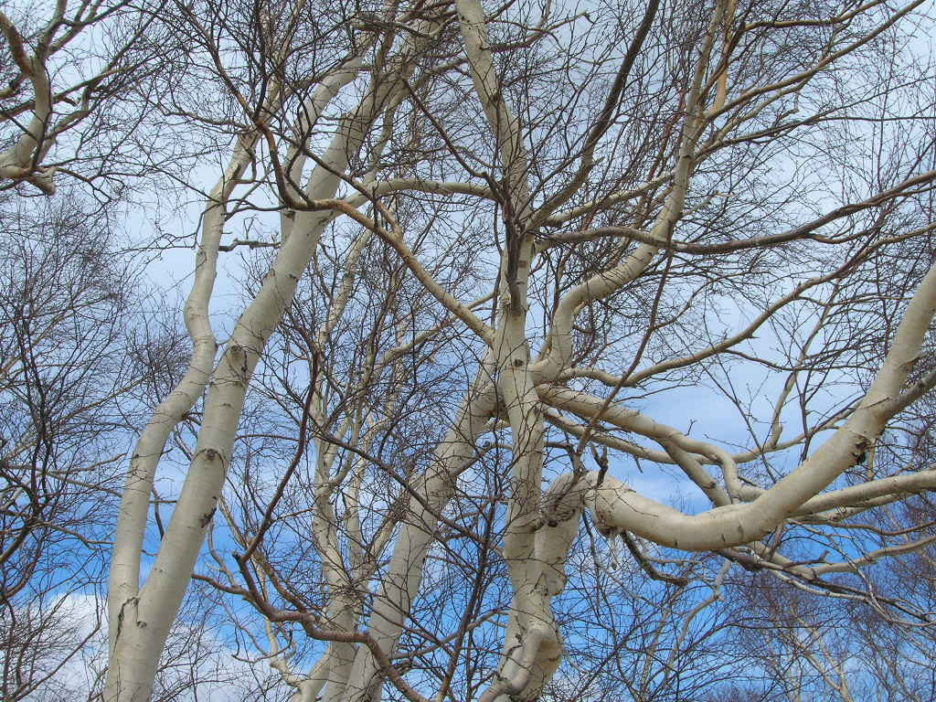
Monte Etna - Sicily (Betula aetnensis)
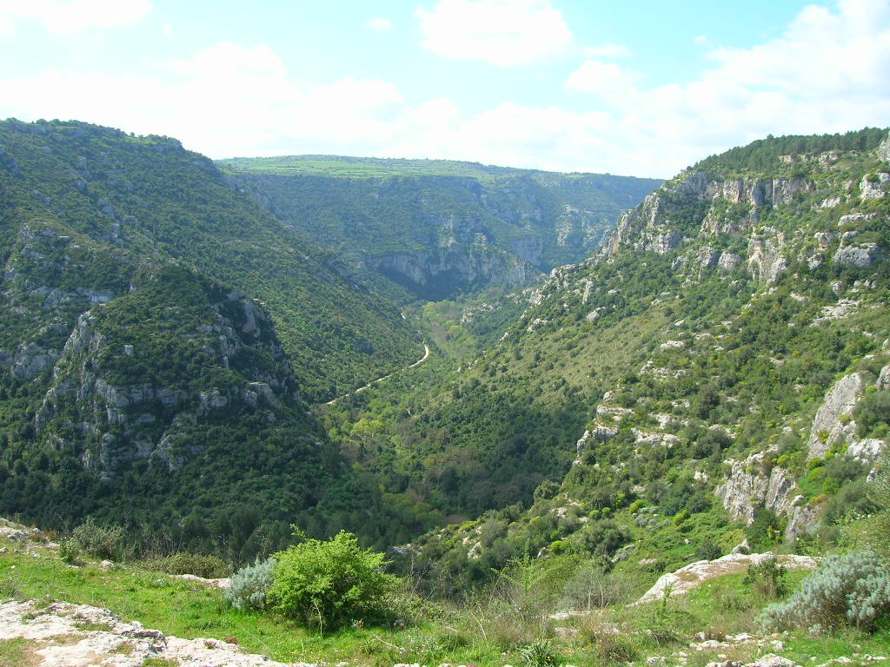
Valle dell'Anapo - Sicily
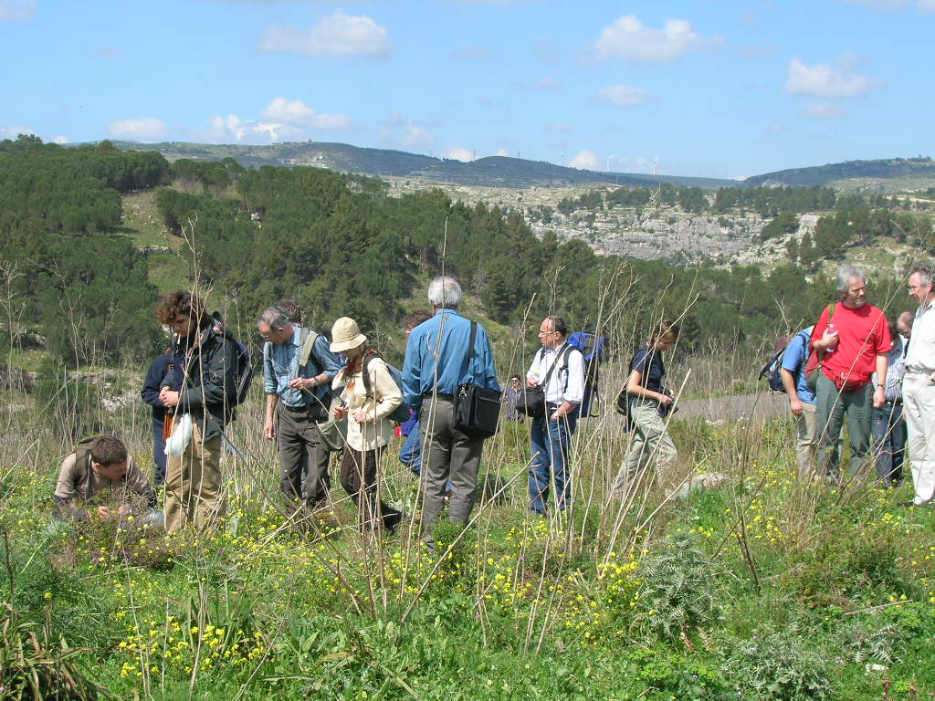
Valle dell'Anapo - Sicily
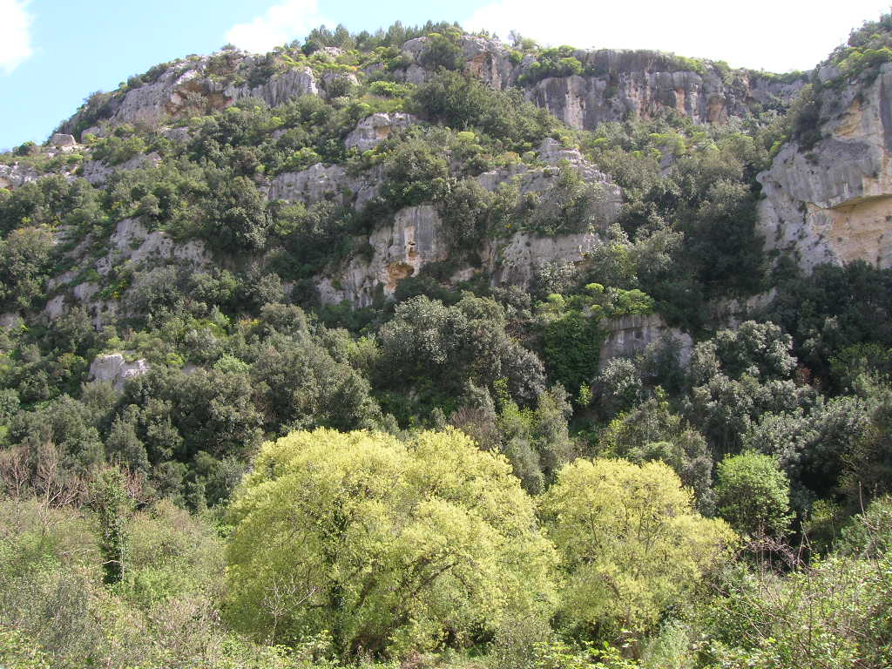
Valle dell'Anapo – Sicily (calcareous cliffs occupied by Oleo-Ceratonion communities)
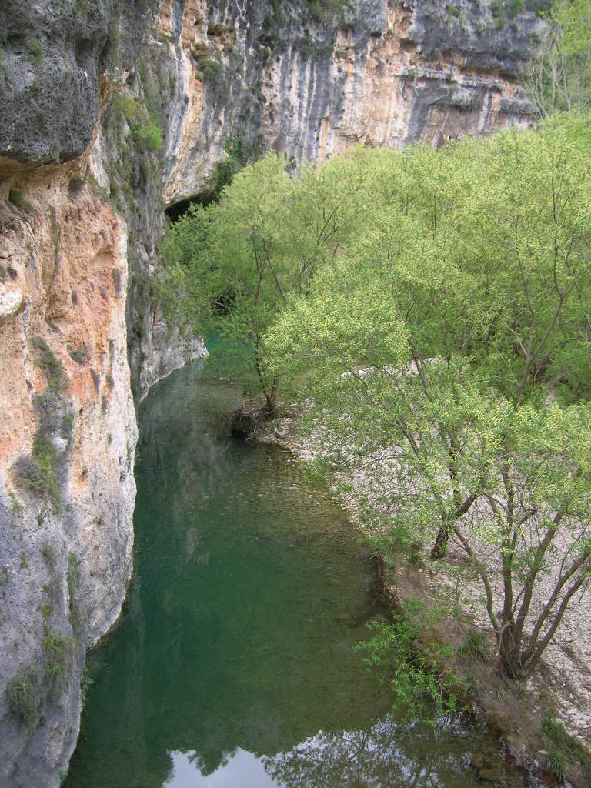
Valle dell'Anapo - Sicily

